**CP Club 365Days Challenge**

**Programming language – C++**

**Problem Statement**

https://www.codechef.com/problems/SCALENE

**Your Code**:

// 0x68Day of 0x365Days challenge

// VEDANT BHARAD

// 24-12-2022

#include <bits/stdc++.h>

using namespace std;

int ScaleneTriangle(int &a,int &b,int &c) {

    if((a<b && b<c)&&(c<(a+b)))

        return 1;

    if((a==b==c==0)||(a==b==c))

        return 0;

}

int main() {

    int t;

    cin >> t;

    while (t--) {

        int a,b,c;

        cin >> a>>b>>c;

        if(ScaleneTriangle(a,b,c)==1)

            cout<<"YES"<<endl;

        else

            cout<<"NO"<<endl;

    }

    return 0;

}

**Output (Screen Shot)**:

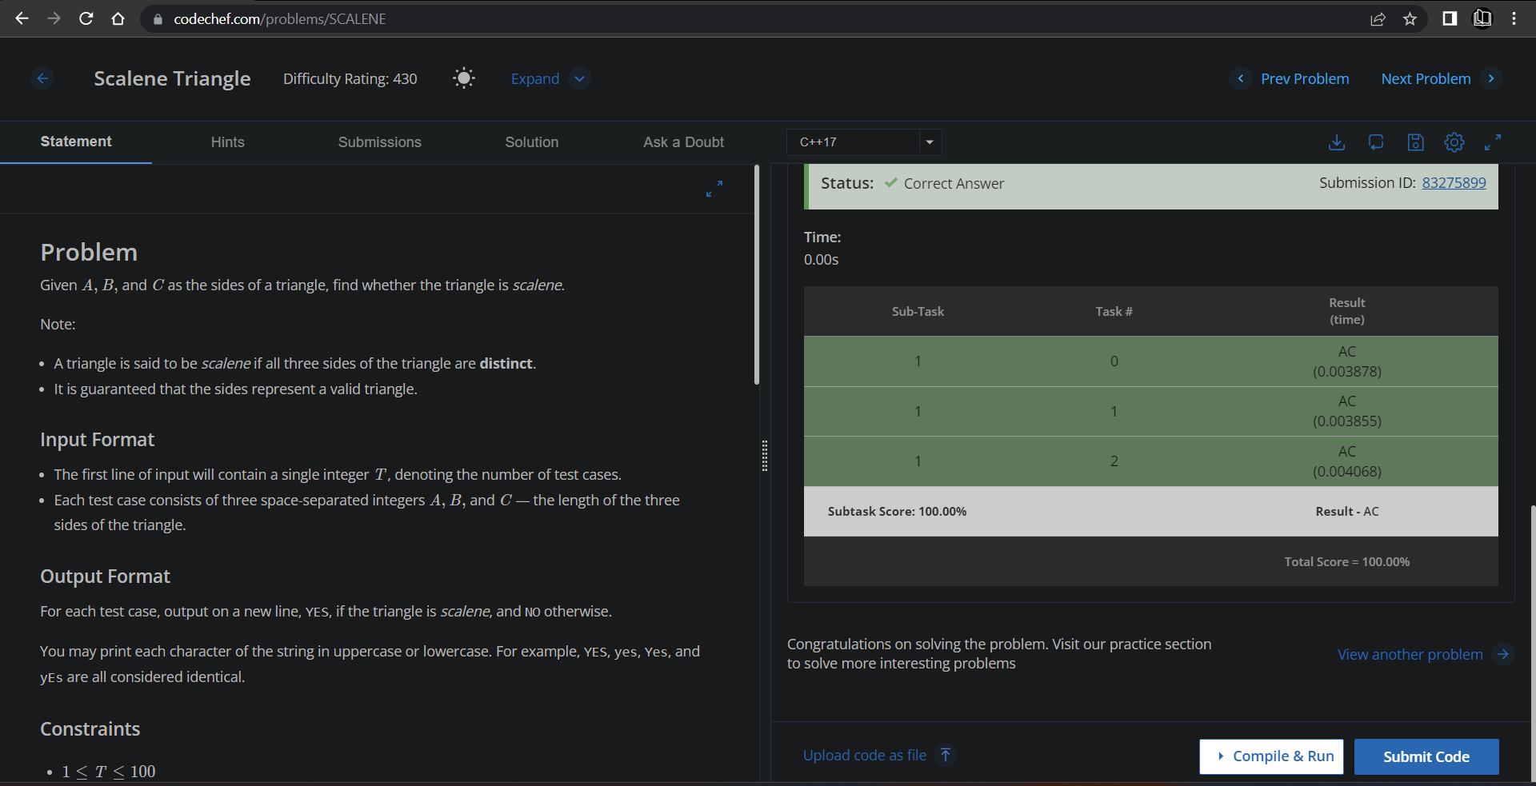

**Understanding about problem:**

* In this task there will be length of each side of triangle and I need to find whether the triangle is scalene or not if it is then return YES else return NO.

Note: If you can't understand the problem, feel free to contact us and we'll help you. Please don't copy and paste from anywhere.

ALL THE BEST

Team CP Club